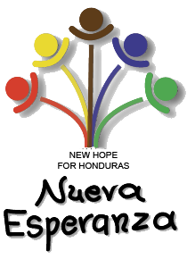

**NEW HOPE**

**HERALD**

**Spring 2017**



**Hope for Learning through Mistakes**

Nueva Esperanza enrolls children from all kinds of family backgrounds. Most of our children are raised by single mothers, others live with a grandparent, and very few children live with both of their parents. Not only are family structures varied, but our children also struggle with a lot of personal issues that they bring to the ministry daily. As we aim to show these children the love of Christ, we also want to do that through the way we teach them about consequences.

Some behaviors that we see among our children here at the ministry are kicking, hitting, and throwing things when they are angry. They may also say unkind words to one another. There is often a lot of fighting and arguing among classmates. A lot of these actions however stem from what might be modeled to them in some form or another.

Since coming to Honduras as a missionary with Nueva Esperanza, I have had the opportunity to work with children who make bad decisions and turn those decisions into opportunities for learning. Instead of simply punishing students for doing something that is against the rules, we strive to work with them to help them learn what some appropriate behaviors might be.

# Table of Contents

• • •

**Page 1: Editorial from the**

**Directors**

**Ready for service…**

**Page 2: New Hope for**

**Mothers**

**Ready for service (continued)**

**Page 3: Keeping in touch**

**with graduate, Ana**

**Raquel**

**Page 4: Family Day**

**celebration**

Mail donations to:

**Nueva Esperanza P.O. Box 345 Kingsville, OH 44048-0345**

Or use our new online giving options at:

[**www.hopeinhonduras.org**](http://www.hopeinhonduras.org)

Email:

**newhopeinhonduras @gmail.com**

Phone: **(814)580-0724**

**(440)224-1497**

**Nueva Esperanza** **Apdo. 4118 Tegucigalpa, D.C. Honduras, C.A.**

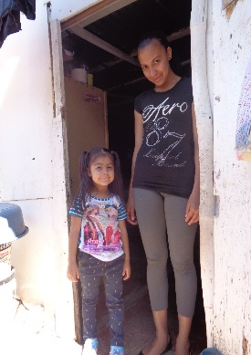

A lot of the children at the ministry struggle with the issue of family instability. That means that the family members in their lives may not be constant, or they might move often to live with different family members. This issue can bring a lot of insecurity. Students may also witness types of physical or verbal abuse. A lot of children live in dangerous neighborhoods where they may also see things that influence their thoughts and actions.

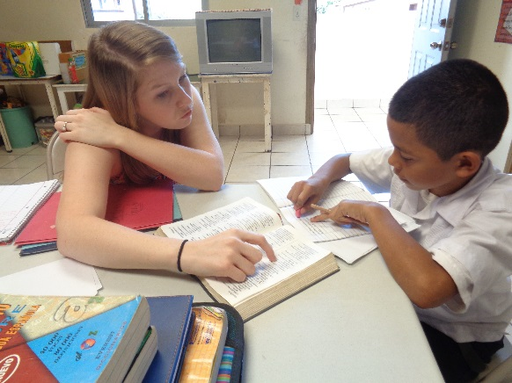

During one of our chapels, we even taught the students what they can do when they become angry. Instead of simply telling these children what they should do, taking time to teach them what they can do and why we make better decisions is so valuable.

**Liz Lovejoy**

**Hope for the Future of Nueva Esperanza Children**

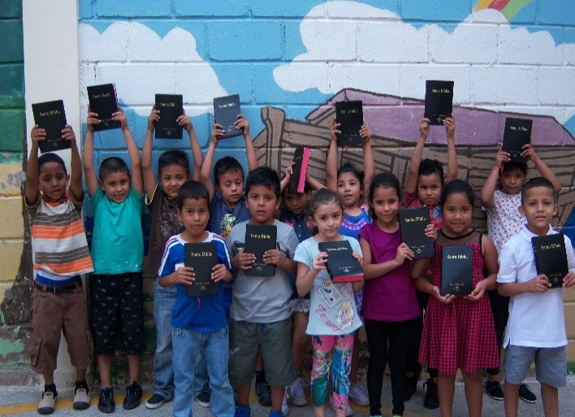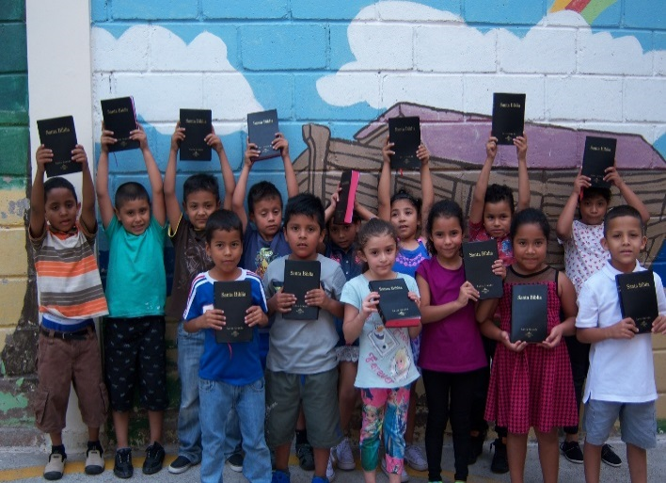

Although Cendy was no longer eligible to continue receiving a scholarship through Nueva Esperanza after the eleventh grade because she did not pass her classes that year, she did make it up through summer school classes and continued at public school. This was also the same time when Cendy’s mother left to live in the United States. By the time Cendy was 16, she was only living with her 19 year old sister. All of her other sisters had moved to the states with her mother. She did graduate from the local high school she attended in 2007.

Cendy got married in 2011 to her husband Jose Elias. He is a general manager at a store that evaluates and sells car parts for European cars. Together they have two children, their son Pablo who is 7 and their daughter Ema who is 1½. Pablo is in first grade at a private, Christian, bilingual school where he has received High Honors for his academics. Ema is a young toddler with a very vibrant personality. Cendy is currently taking care of her kids and studying Marketing at the local university. She plans on graduating with her Bachelor’s degree in March 2018.

Nueva Esperanza had a great impact on Cendy’s life. She expressed that her life now is very different from any of her siblings. They never graduated from high school, and she is now in college. She’s happily married and able to provide her son with a private, high quality education.

As Nueva Esperanza closes in on its 25th year, there have been 451 students enrolled in the ministry past and present. It is a joy to be able to see past students visit and tell us how their lives have changed because of the ministry. During our with event with the Prayer Team that came to visit the ministry, Cendy, who was four years old when she was enrolled at the ministry in 1994, came to visit. She had met Lester, the leader of the prayer team, back in 1999 when he first came to the ministry and surprised him with her visit. She brought her two children and niece with her as well for the surprise.

poor area near the ministry. Her father did not help much financially and went to visit on occasion. Cendy’s mother Rosa decided to fill out an application for Nueva Esperanza because she wasn’t able to take care of Cendy and make sufficient funds to take care of the rest of her children. So, on July 4, 1994, Cendy joined the ministry.

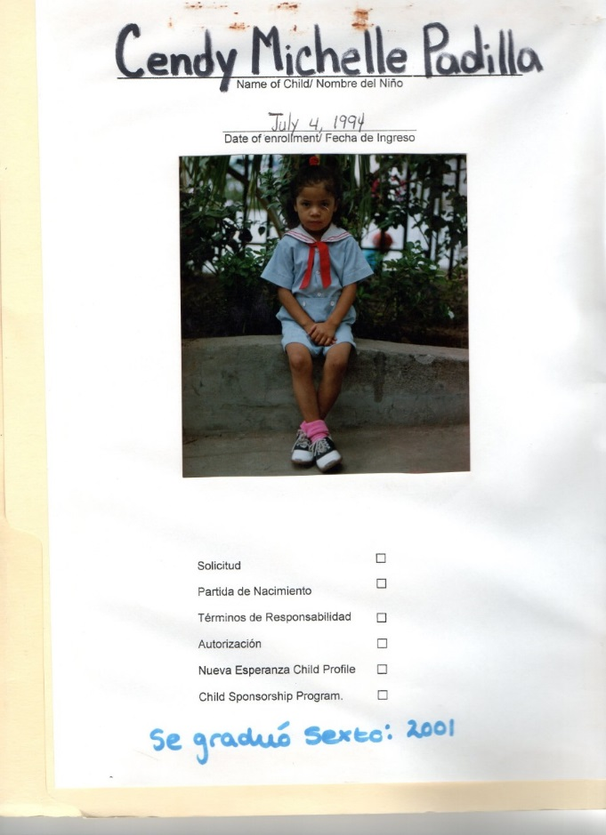

Cendy’s story of how she came to Nueva Esperanza was much like many other children who have gone through our program. Cendy was the youngest of 5 children when she was enrolled, and her family lived in a wooden house in a very

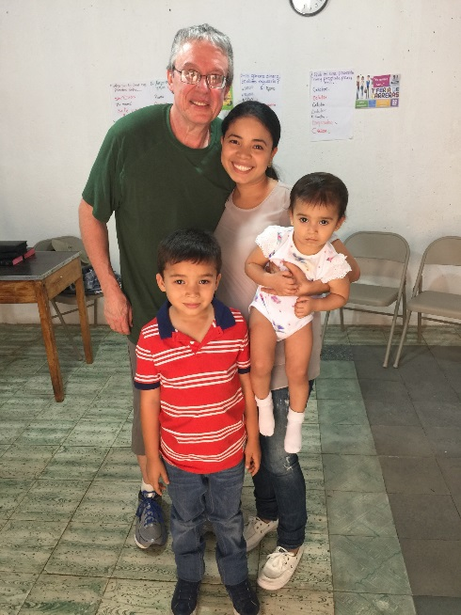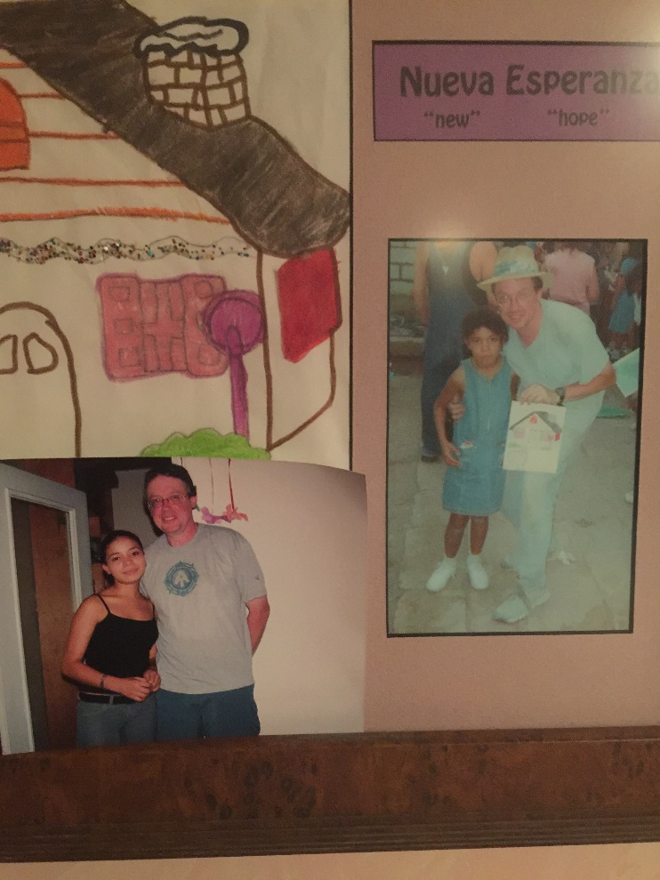

(After talking with) Cendy, (she) expressed that once she started attending Nueva Esperanza, she always had school supplies, sufficient meals at the ministry, and even Christmas gifts. These were often things that her sisters lacked because they were not a part of Nueva Esperanza. She

Cendy was moved to tears as she expressed how much the ministry was able to provide for her physically, spiritually, and educationally. she believes the opportunities she had a Nueva Esperanza helped motivate and encourage her to ensure that her children grew up differently than she did.

also explained that Nueva Esperanza is where she learned about God. Her mother did not take her and her sisters to church or ever talk about God at home. She also learned good morals and how to treat and relate with others.



Week of

**praying**

**WOW!** What a wonderful week of praying, sharing and caring! Our very first Prayer team week was made up of five people from the State of Minnesota, one from West Virginia, two Americans living in Honduras, and of course, Carlos and Barbara. We are already planning for next year and would love for YOU to join us!

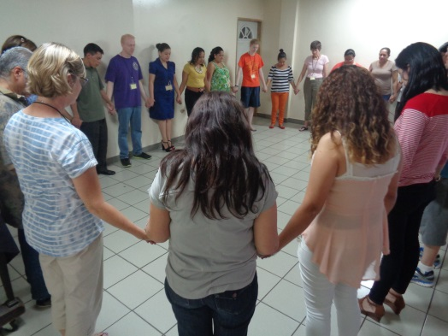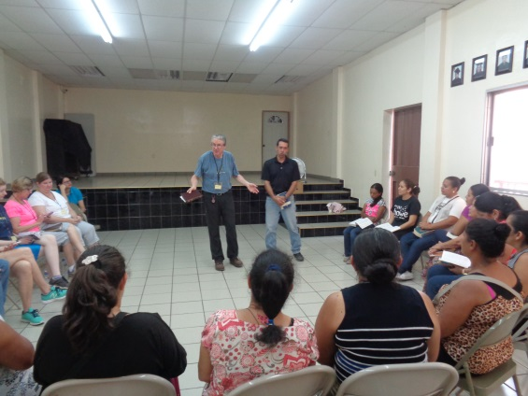

**Praying and sharing with the Children’s Mothers**

**Prayer time with the Staff**

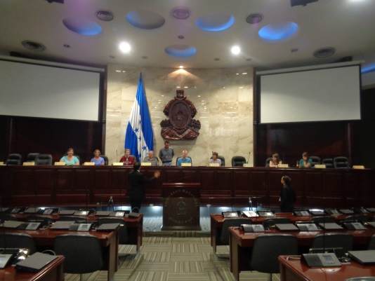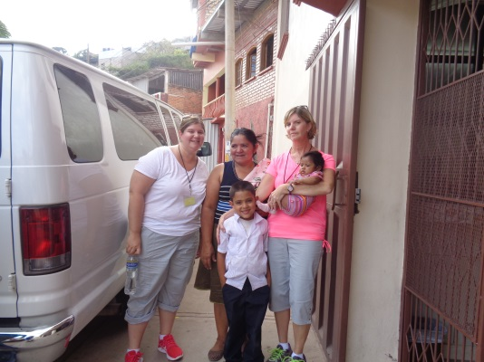

**We had the opportunity visit some government buildings and learn some history to know better how to pray for the country.**

**Home visit to deliver a bunk bed for one of our families.**

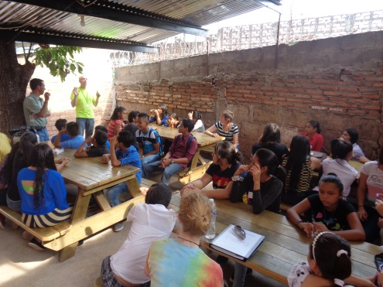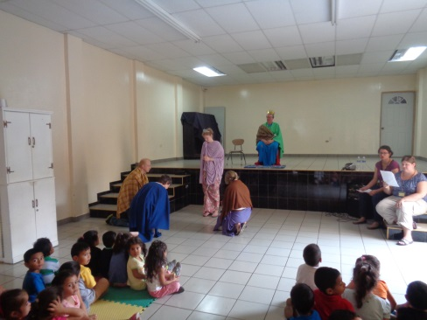

**Teaching the children about prayer in chapel through the story of Esther**

**Sharing with our youth.**

**CHILDREN**

**W**

**E**

**N**

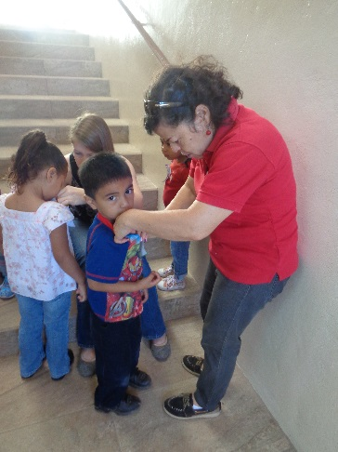

In March, we were able to welcome 13 new children into our preschool and kindergarten classes! They have now been here for about a month. This is currently a time when these new students are adapting to routines and rules at the ministry. So far, they have all be adjusting very well. All of our new students are between the ages of 3-5, and we accepted enough children to fill our two preschool classes and one kindergarten class. It has been exciting to see them making friends, learning new things, and becoming a part of our Nueva Esperanza family.

All of these children will need sponsors in the coming months! Usually we wait to get sponsors for these children for a few months so that we have time to build relationships with their families. Along with these 13 new children, we still have about 45 other children and youth who are in need of sponsors. If you have any questions about child sponsorship or our youth sponsorship program, please email us at [nesponsorship@gmail.com](mailto:nesponsorship@gmail.com).

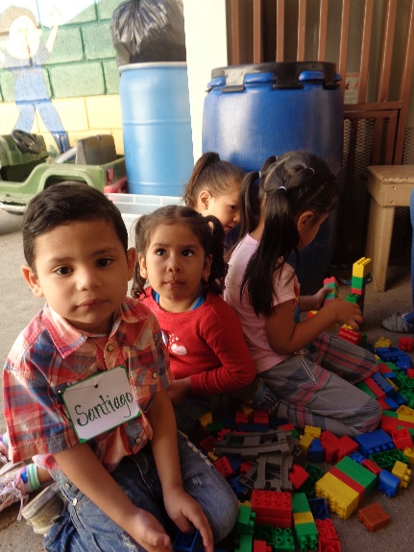

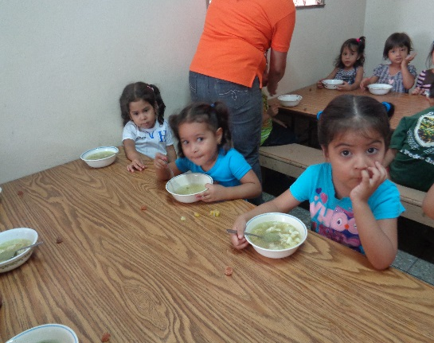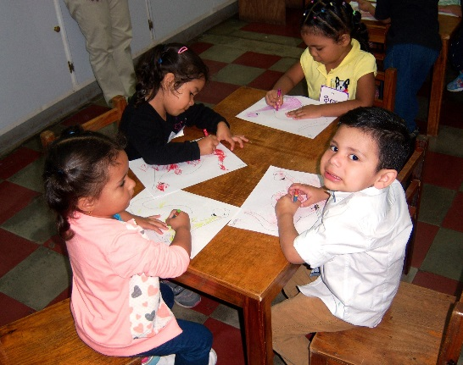

We now accept online donations at [**www.hopeinhonduras.org**](http://www.hopeinhonduras.org)!

Or complete and return this section along with your contribution to our Ohio address.

Thank you for **Bringing NEW HOPE to needy children**

My one-time donation: $­­­­­­­­­­­________________

My monthly pledge: $­________________

To be designated towards:

 Bibles

 General operating expenses

 Worker/teacher support

 High school sponsorship

 Barahona family support

 New youth center

 Wherever the need is greatest

**I want to sponsor a child!**

* I want to be a monthly educational sponsor ($30)
* I want to be a monthly basic care sponsor ($30)
* I want to be a monthly daily care sponsor ($30)

If you already know which child you want to sponsor, please list

his/her name: ____________________________________

Name ________________________________________________________

Address ______________________________________________________

City _________________________ State _________ Zip Code________

Email _________________________________ Phone _________________

**Make checks payable to: Nueva Esperanza.**

Please add my name to the mailing list.